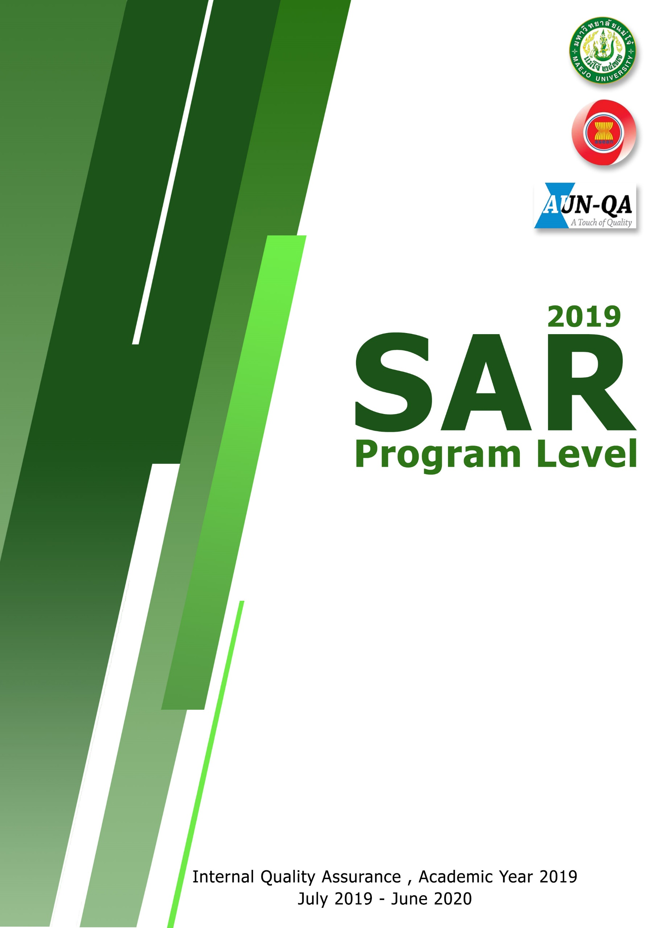
–
Master of Science Program in
Resources Development and Agricultural Extension

