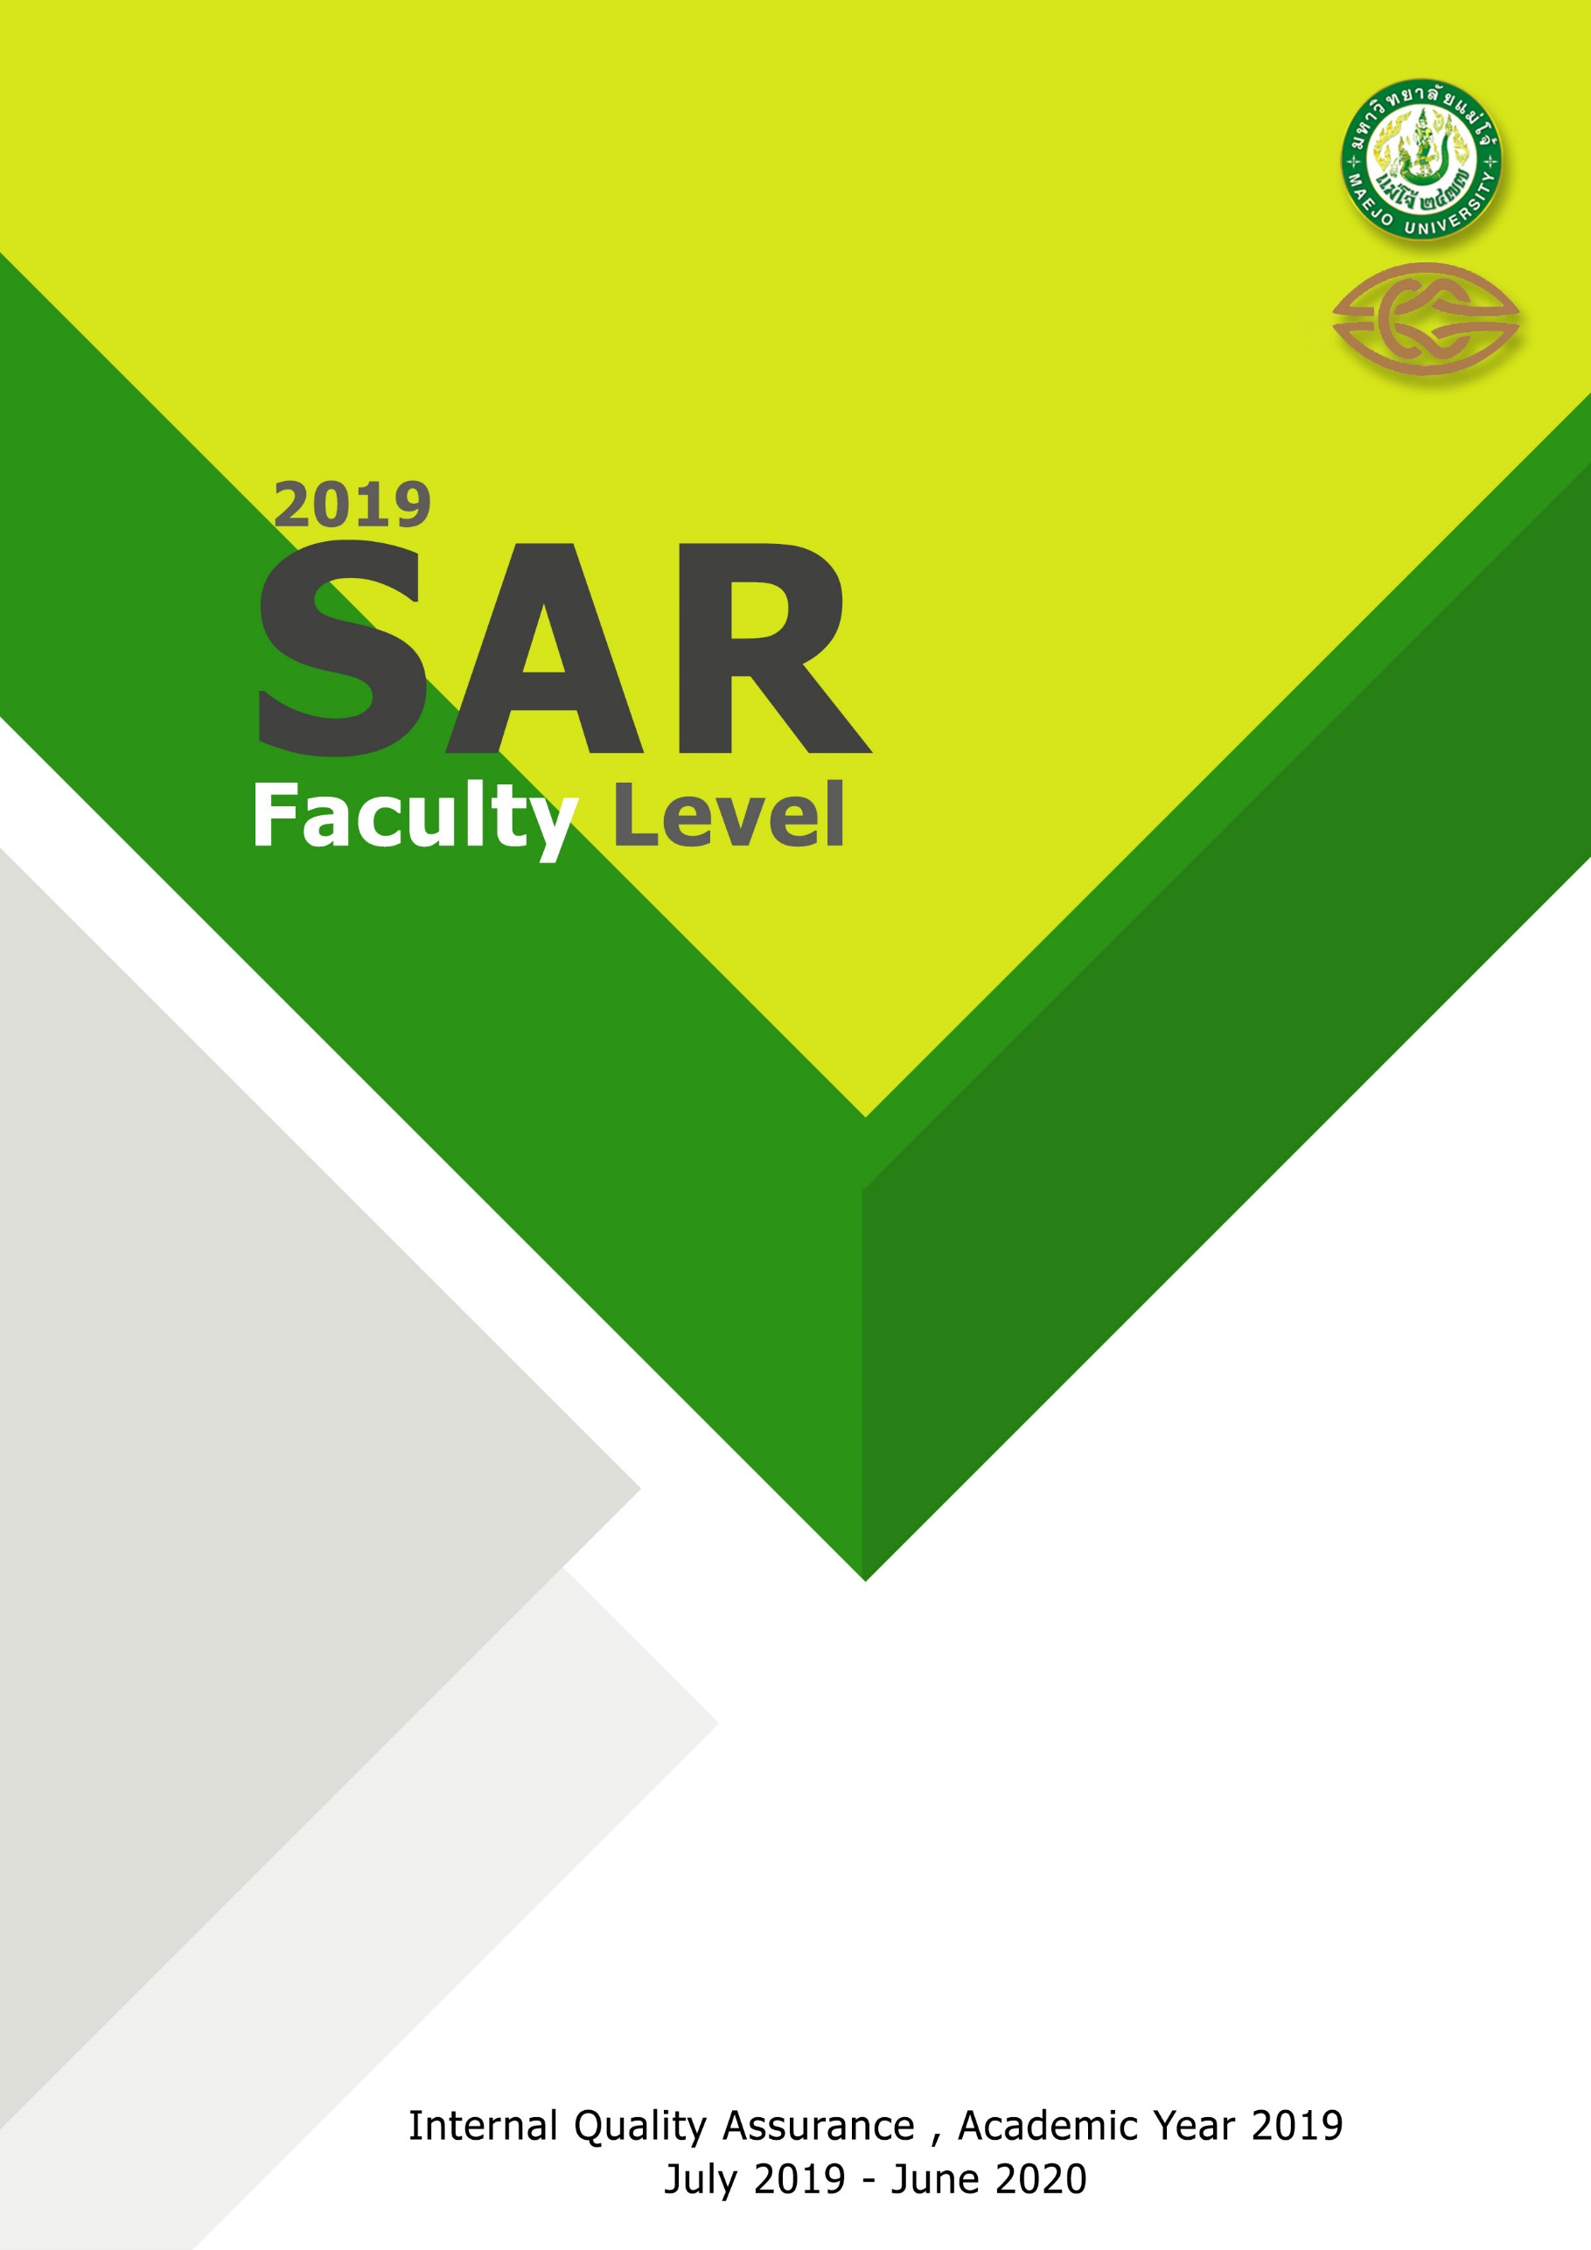
Faculty of Architecture and Environmental Design

