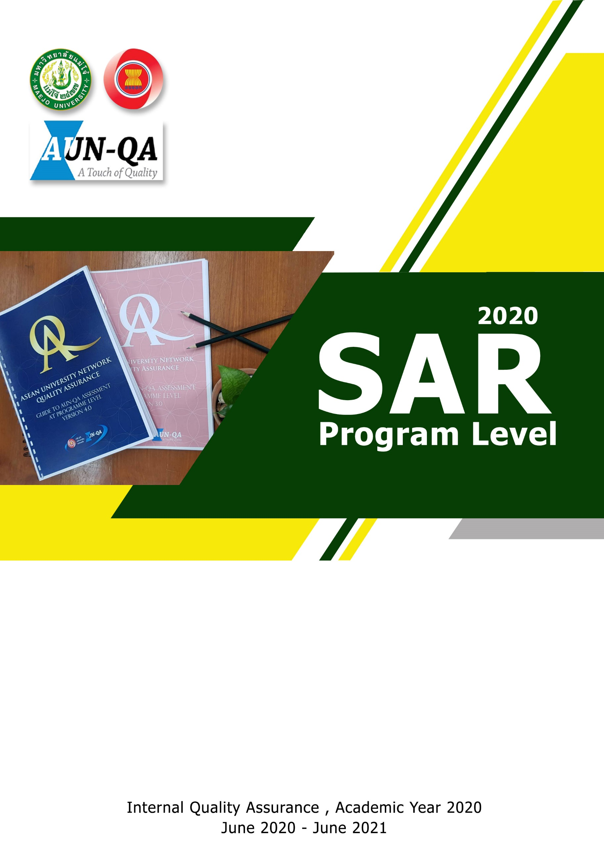
Master of Science Program in
Resources Development and Agricultural Extension

Faculty of Agricultural Production , Maejo University
Chiang Mai , Thailand

