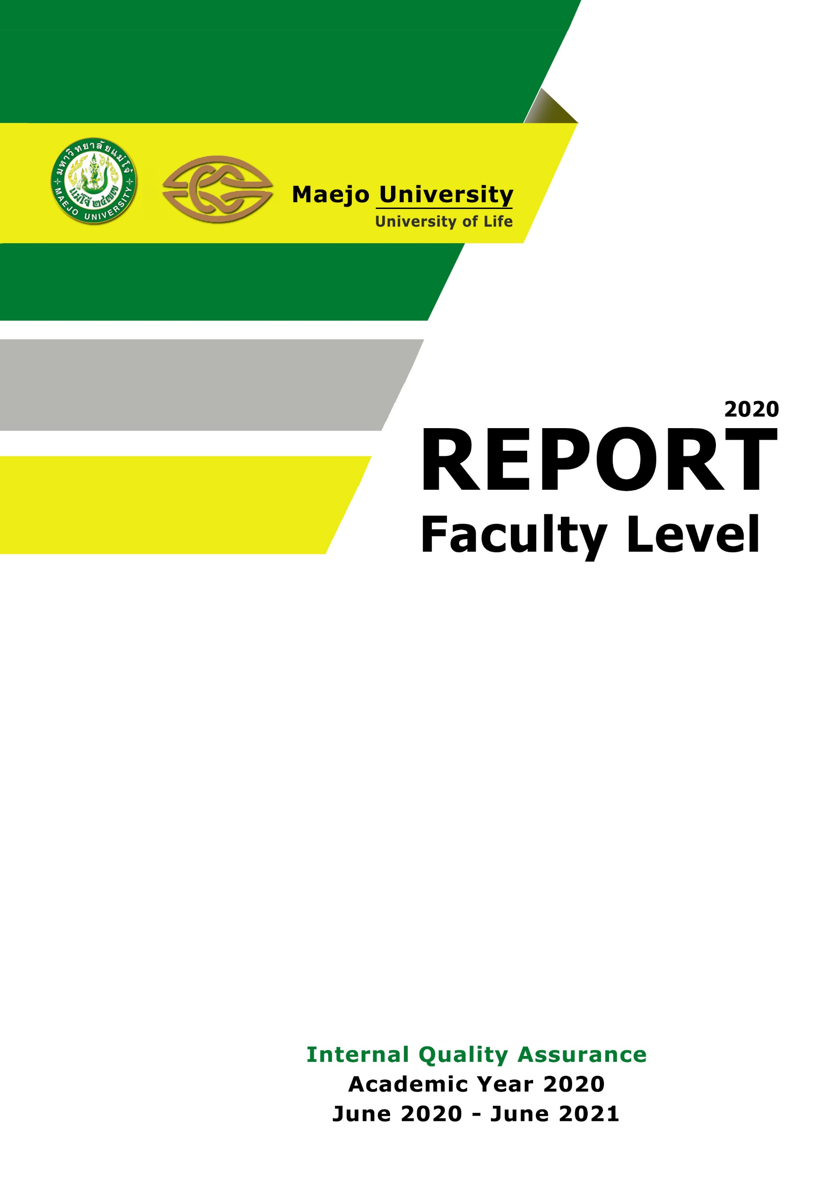

Faculty of Agricultural Production , Maejo University
Chiang Mai , Thailand

